**Smart Home Automation System**

**Description: Develop a simple smart home automation system using OSGi bundles to control various smart devices within a home environment.**

**Security System:**   
Implement bundles for managing security cameras, door locks, and motion sensors. Users can monitor their home security status and receive alerts for any suspicious activities.

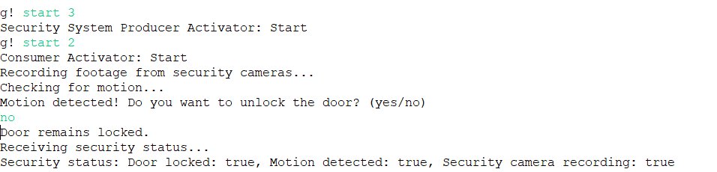

Figure 1: Door remains locked when entering No

Figure 2: Unlocking the door when entering yes and also lock all the doors , on all cameras and started recording

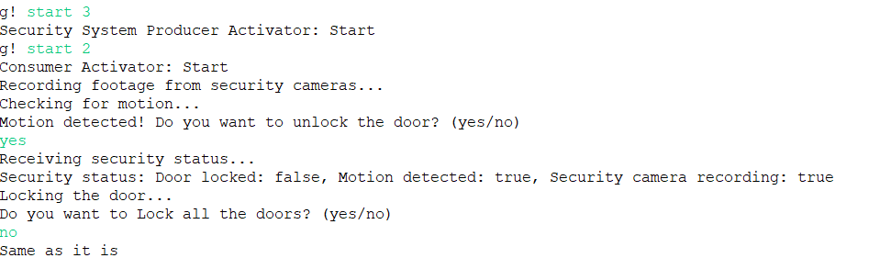

Figure 3: Unlocking the door when entering yes and not closing all doors

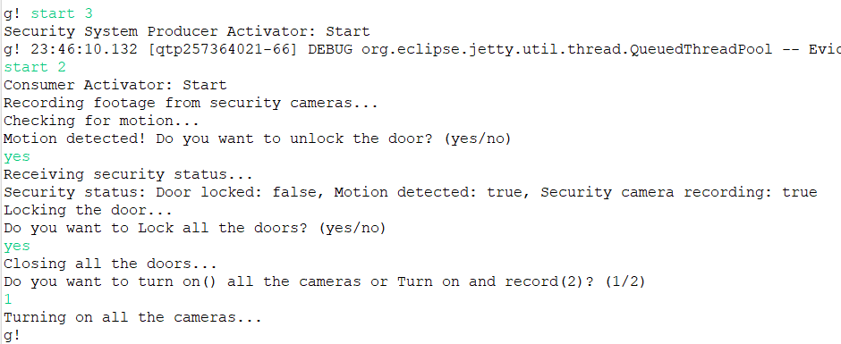

Figure 4: Unlocking the door when entering yes and also lock all the doors and turn on all the cameras

Figure 3: SecuritySystemConsumer Manifest.MF

Figure 4: SecuritySystemProducer Manifest.MF